How to print with staples at the printer in 1.72 from your Mac:
The Xerox Model of the printer is wc7556.
You may need to download the driver wc7558.dmg and install it.
http://www.support.xerox.com/support/workcentre-7545-7556/downloads/enus.html?operatingSystem=macosx1010&associatedProduct=XRIP_WC7525_base
Select built-in controller

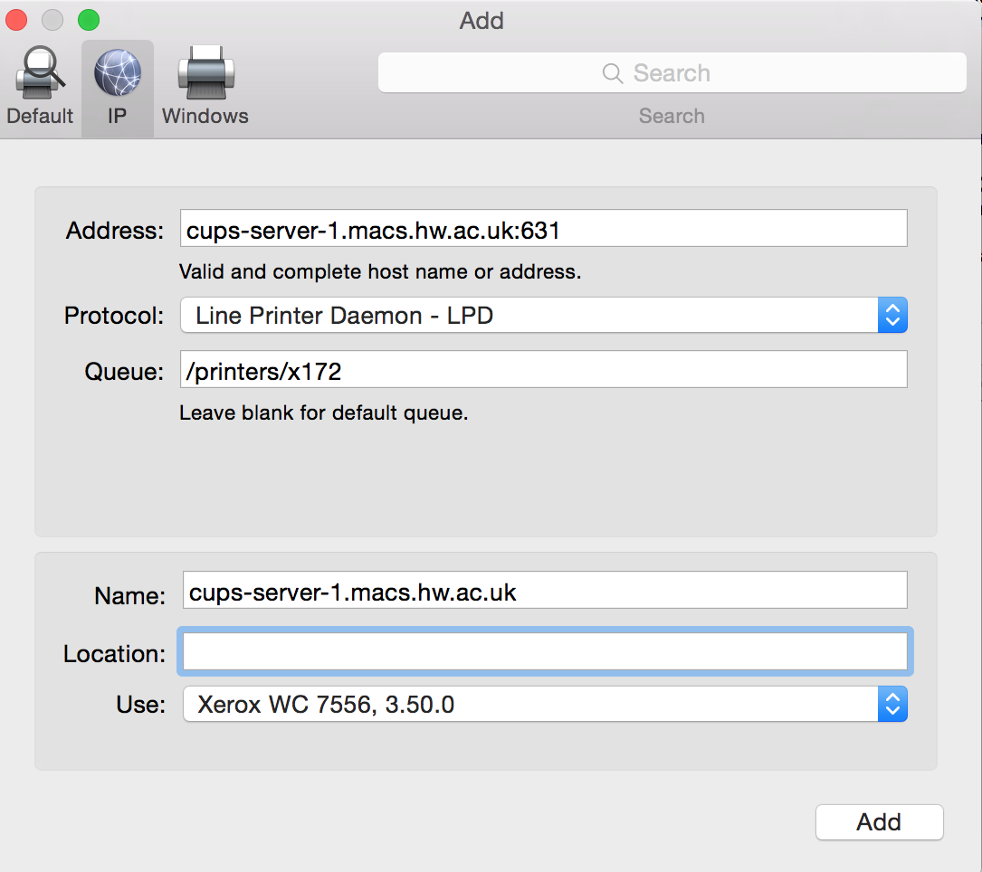
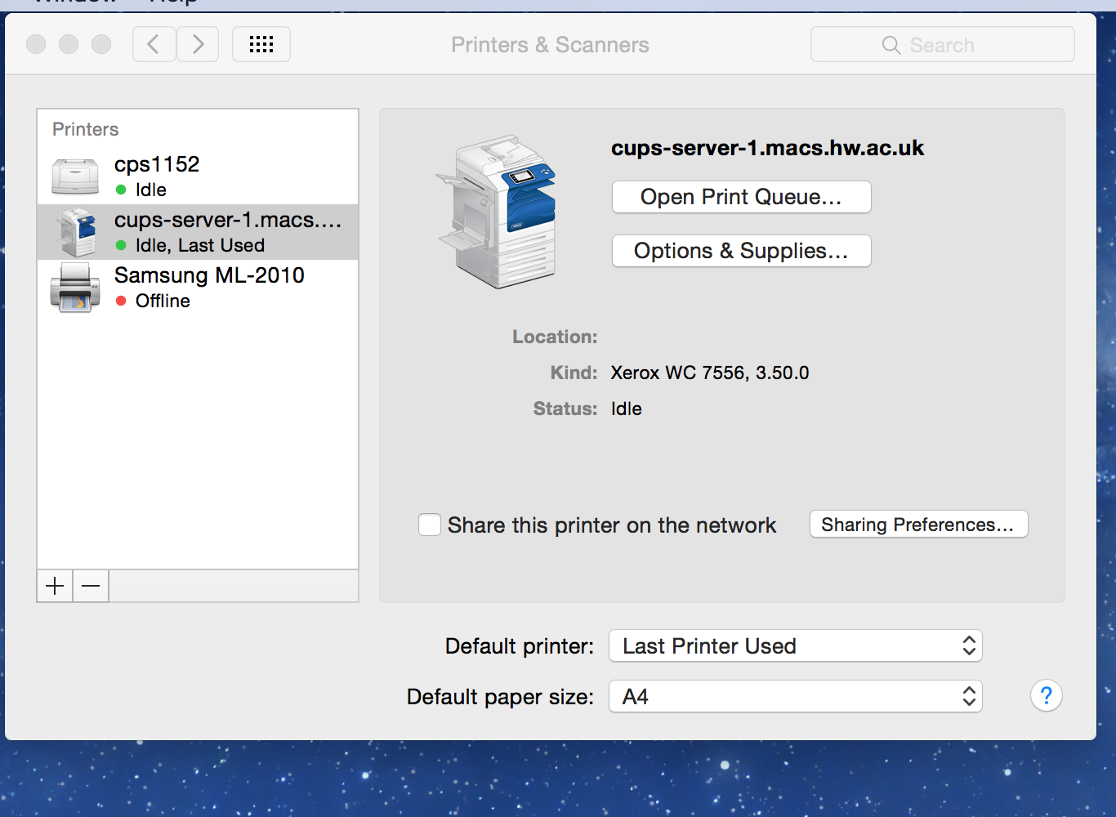

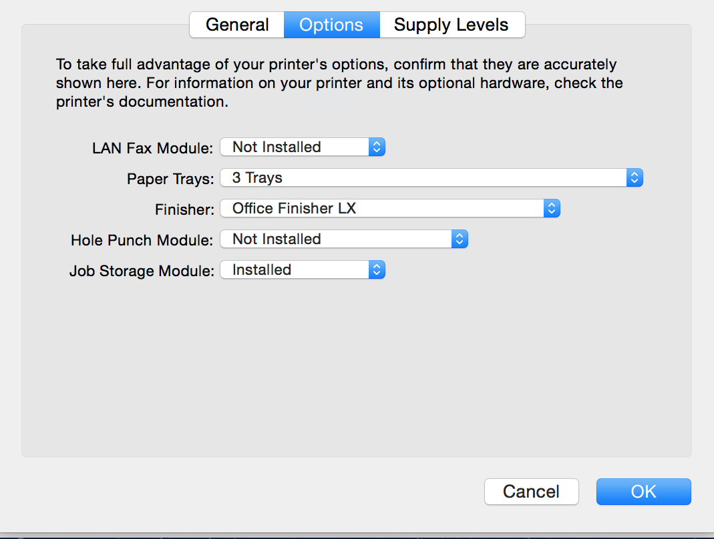

If it adds the printer then you should be fine. However if you get the error then follow the rest of the steps outlined here. 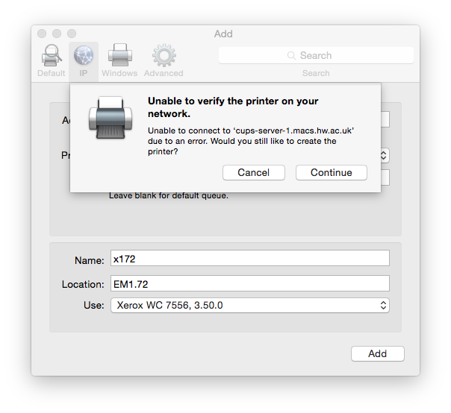
Open a terminal and stop your cupsd
sudo launchctl stop org.cups.cupsd
Edit the configuration of the new printer by
sudo vi /etc/cups/printers.conf
Find the printer you’ve just added, it should be the last one in the list. Find the line
AuthInfoRequired none
and change it to
AuthInfoRequired username,password
Now restart cupsd
sudo launchctl start org.cups.cupsd
When you send a job to the printer, a dialogue box will pop up. Change the username to your school user name, e.g. ajg33, and enter in your school password.

