Modelling of Secure Data Transmission over a Multichannel Wireless Network in Alloy
Aliaa M. Alabdali, Lilia Georgieva, Greg Michaelson
MACS, Heriot-Watt University, UK, Edinburgh, EH14 4AS
aa989@hw.ac.uk, L.Georgieva@hw.ac.uk, G.Michaelson@hw.ac.uk

Abstract-This paper proposes a modelling and verification approach for data transmission over a multichannel wireless local area network (WLAN). The approach uses typed first-order logic as a specification language.
We analyse a system which transmits data securely in the presence of the classic Man in The Middle (MitM) attack using Alloy.
We develop a methodology for representing secure message exchange on a multi-channel WLAN which uses a changeable array and indices, instead of the message itself so that we can avoid both passive and active MitM attacks.
We analyse the model for vulnerabilities and specify assertions for secure data transmission over a multichannel WLAN.

Keywords: network security, multichannel WLAN, Alloy, MitM,

Introduction
In this paper we investigate the use of the first-order logic modelling tool Alloy in order to ensure data privacy and confidentiality over a multi-channel wireless network.
Wireless networks have become pervasive. They have millions of users and enable convenient and flexible information exchange among devices such as notebook computers, PDAs and Tablet PCs, but also among mobile phones, digital cameras, and hand-held games with numerous benefits of mobile.
Their growing number of
users and intensive use reveal vulnerabilities. Wireless networks can be
compromised in a number of ways: the wireless channel can be eavesdropped; the data transmitted over the network can be altered; identities of the communicated parties can be impersonated; the communication channel can be overused or jammed [1].
The rapid commercialization of new products and services which use wireless networks does not allow enough time for the design of robust security architectures [5]. Consequently, the risk of losing and misusing data transmitted over a wireless network is high [6], [7]. As a result, investigation into ensuring information security on a wireless network, e.g. by using strong key, transmitting data over pairs of nodes and encryption has been identified as paramount [2].
In the context of wireless networks, preserving information security has three main goals: (i) confidentiality, i.e. ensuring that nobody but the receiver can see the information; (ii) integrity, i.e. ensuring that the information has not been modified, and (iii) availability, i.e. ensuring that anytime the information is needed, it would be available [8]. Our approach uses the model analyser Alloy which has been shown to be a valuable tool for improving the design of security protocols [10]. Typed first-order logic, in which Alloy models are written, allows us to specify communication flow, characterize the participants in the communication, and formulate assertions which would guarantee security.
We model secure transmission over a two-hosts two-channel wireless network. We consider the transmission in the presence of a man in the middle (MitM) attack. In MitM, the attacker takes advantage of weak network communication protocols in order to convince a host to route the information through the attacker instead of through the normal router. The attacker intercepts messages in a public key exchange and then resends them after substituting their own public key for the requested public key [25]. Hence, the attacker makes two hosts believe that they are communicating with one another while the attacker controls and modifies the communicated messages.
The attacker attacks in real time by splitting the original TCP connection into two new connections and acting as a proxy where they can read, insert, and modify the data in the intercepted communication.
MitM is commonly deployed in communication over a single-channel WLAN as multichannel authentication security protocols offer a promising way to ensure data integrity and originator’s authenticity between hosts using devices such as Personal Digital Assistants (PDAs) whose owners have no past interactions and no access to a Public Key Infrastructure (PKI).
While security systems depend on strong mathematical foundations, it is nonetheless hard to establish formally that an implemented system actually embodies desirable security properties.
In this paper we explore the use of typed first-order logic to model and hence analyse such a communication system, using the model analyser Alloy. We assume perfect encryption and study a scenario of a secure data transfer between a customer, her bank and an ATM as an illustration of the capabilities of the modelling tool.
The encryption scheme that we consider is generating changeable array. A message is transferred as a sequence of indices based on this array. The array and indices are stored in external files and these files are transmitted over two channels WLAN instead of the message itself.
The structure of this paper is as follows. In section II, an overview of Alloy analyser is presented with modelling a simple model. Section III illustrates our case study describing the structural and procedure of the system. In section IV, brief summary of the MitM is introduced. Followed by section V which models data transition security over multichannel wireless in Alloy. Section VI represents some works related to our case study. In the last section the brief of this approach and the future directions of our research are discussed.

Model ANALYSIS in Alloy
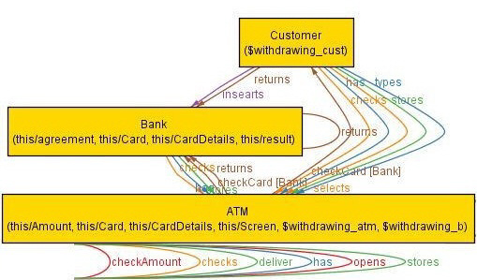
Model analysis using Alloy allows for representing systems that are characterised as automata with strong logical properties of transitions. Typically, a model is visualized as a set of limited model instances. Alloy provides a simple model specification language which relies on first order logic and visualises object models using graphical and textual structures. A model’s behaviour can be constrained by predicates and assertions within a limited scope [29].
Alloy models consist of a set of signatures defining object sets and connecting them through relations. Alloy performs model analysis by finding proper model instances that is instantiations of variables in the model characterisations that satisfy some determined property. [28]. The modelling language of Alloy is textual and declarative [9]. An instance of a model in Alloy is a collection of entities and relations that satisfies all the model constraints. In Alloy, each basic type has an assigned limited scope identifying the maximum number of members that the type can have.
Alloy models contain signatures (sig), facts (fact), functions (fun), predicates (pred), and assertions (assert). The Alloy analyser works by enumerating all possible instances of a model within the scope. In this way it can find examples (instances that satisfy a predicate), counterexamples (instances that falsify an assertion), and verify assertions (when within the given scope, all model instances satisfy the assertion). If there are no instances of a model, then the model is inconsistent [9]. Thus, Alloy provides two kinds of analyses: simulation which examines the coordination of a given predicate by generating a state of the model that satisfies that predicate; and checking whether an assertion is valid or by trying to generate a counterexample. The generated counterexamples allow us to trace the properties that violate the specification.
The predicates and assertions in the model are translated into a Boolean formula, which is passed to the SAT solver. The SAT solver attempts to find instantiations of formula variables to guarantee that the formula is satisfied. Once an instance is found, it is converted back into Alloy. Because of the limited scope of models in Alloy the assumption that counterexamples nullifying a model are most likely to be found in small models instances is implicit [28].
Such lightweight modelling, as used in Alloy, is a design technique in which small, abstract formal models are explored and verified with a push-button tool.
In this paper, we consider small, abstract models of transmission of data over a wireless network, explore the properties of candidate models using a push-button analysis tool, and verify aspects of the final model using the same tool.
The Alloy analyser has become increasingly popular and is applicable in a variety of different applications. For example, in [30] a design visualising the possibilities of detecting a MitM attack while using a credit card for paying online is investigated. Alloy has been used to model the efficient and Secure Card-based Payment System (ESCPS) with no counterexample found. In [28] Alloy is used to automate the specification and verification of an Aspect UML model used in Aspect oriented (A-O) programming. In [31] the Alloy analyser is used to explore design weaknesses at early stages of software development in an e-commerce application vulnerable to MitM. Alloy has also been used for modelling and analysis of protocols in networks [33], distributed systems [32], and mission critical systems [34] and to model and emulate the partial and complete attacks [35].

A central part of Alloy's modelling specification is signatures. Signatures define the entities of a system and introduce basic types and relations between them, allowing for visualization of the relations among such entities using

Fig. 1 A simple example for data transition and exchanging keys in Alloy

the graphical user interface of Alloy. Signatures also allow for representation of a data domain and its structure.
A signature extension is utilized to support pyramidal specification. Signatures can inherit fields and constrains from, and be defined, as a subset of other signatures.
Consider the realistic example illustrated in Fig. 1 which shows simple transmission and key exchange and is based on a scenario where the customer is using an ATM. For our specific example, as an illustration, we introduce the following signatures:

sig Card in Bank {} sig CardDetails in Card {}
sig Amount in ATM {} sig Screen in ATM{}
sigresult in Bank{} sig agreement in Bank{}
sig Customer extends Bank { inserts: one Card, types:CardDetails, selects:Amount, }
sig ATM {checkCard: Card ->Bank, opens: Screen, checkAmount:Amount->Bank, deliver:Amount }
sig Bank extends ATM {checks:checkAmount, has:Amount, stores:CardDetails,
returns:agreement }

Signatures correspond to objects, whose names are self-explanatory. The keyword in defines a subset relationship, whereas the keyword extends adds richness to the specification, e.g. in the above example the bank signature extends the ATM signature to inherit all of its fields and restrictions.
While the defined predicates do not impact on the configuration of the formula that is being analysed, predicates impose interim restrictions. Consider the following specification:

pred PasswordAndCardDetails
( cust:Customer, b:Bank, atm:ATM)
{( b.stores<:CardDetails = atm.checkCard[CardDetails] => cust.insearts<:CardDetails= b.stores<:CardDetail )}
pred amount( cust:Customer, b:Bank, atm:ATM)
{ (atm. checkAmount[Amount]= b.has<:Amount)}

The first predicate above specifies that a bank stores the customer’s details as soon as she has inserted her card. The second predicate stipulates that, when the customer tries to withdraw an amount of money, the ATM machine needs to check that she has enough amount of money in the bank to cover the withdrawal.
Checking such predicates based on all aspects of a model requires checking the running traces of the model for consistency. Alloy introduces a library to deal with ordered lists of these aspects.
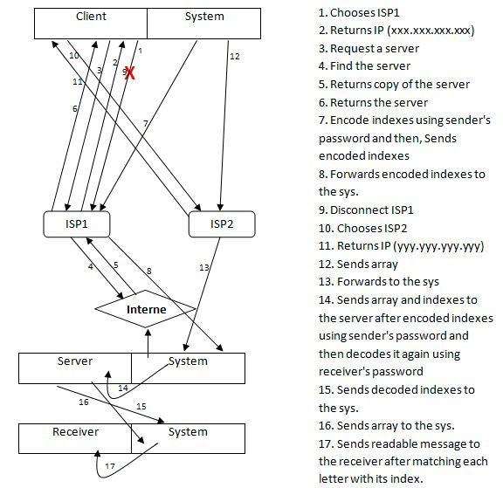
A predicate is verified through an assertion, which tries to find out an instance that satisfies the model, taking into account the restrictions of the predicate that are being analysed [28]. When an assertion is violated, Alloy produces a counterexample which is useful for analysing the potential security breaches of a network transmission. A consistency checker and a counterexample extraction are tools customized for Alloy. They are entirely automated and depend on integrated SAT solvers. The consistency checker is responsible for evaluating predicates on specified models. Assertions are used to check if a model generated by the relations satisfies certain characteristics. If that is not the case, the analyser produces a counterexample, which is an instance of the objective model where that characteristic is not satisfied. If that is the case, the output is that no counterexample is found.
For a model to be sound, all relations based on predicates, signatures and model instances must be true. An assertion enables identification of counterexamples which are generated by Alloy. We use the example below to show condition => predicate:

assert withdrawing
{ all cust:Customer, b:Bank, atm:AT |
PasswordAndCardDetails [cust, b, atm] and
t
amount [cust, b, atm] implies
b<:returns[agreement] = atm<:opens[Screen]
and (b<:returns[agreement] = atm<:deliver[Amount])
else
!( PasswordAndCardDetails [cust, b, atm] or
amount [cust, b, atm] ) implies
!( b<:returns[agreement] = atm<:opens[Screen] and !(b<:returns[agreement] = atm<:deliver[Amount]) )}
check withdrawing

The first assertion in the preceding example states that a customer cannot get to the screen for withdrawing money unless the ATM machine checks the correctness of data entry and the card details from the bank.
Once the ATM establishes that the data on the card and data entry equals the one stored by in the Bank, a withdrawal screen is displayed for the customer to select an amount of money to withdraw.
When the customer selects the amount of money to withdraw, the ATM checks whether the customer has enough money. Only after a confirmation that this is the case, the ATM provides that amount to the customer.
If the ATM finds that the data on the card and data entry are not equal to the ones stored in the Bank, or if the customer does not have enough money then the ATM will neither open the screen for withdrawing nor provide the money, and instead the transaction will be cancelled.

Case study
We now explore in detail the substantive case of intercepting a message submitted over a single channel through a Man in the Middle (MitM) attack. We show how the use of multichannel communication may evade MitM because once one channel is hacked; the MitM will not get readable information because such information should come from data transferred over both channels.
In a multichannel system, extra channels are added to the basic channel responsible for transmitting the largest amount of data security. The extra channel always has stronger characteristics than the main channel and can be wired or wireless [11]. Here we explore the case with two wireless channels.
The model consists of three systems: (i) for the sender to analyse message into array of letters and indices with encoding indices , (ii) for the server to decode indices and re-encode indices using receiver’s private code, and (iii) for the receiver to decode indices and match letters with indices to get original message. We assume that there is just one MitM between two hosts transmitting an email message over two wireless channels. The model is shown in Fig. 2

Fig. 2 Model of system data transmission over multichannel WLAN

In Fig. 2, the numbers correspond to steps in the communication process. The first step is when the sender connects to a wireless network choosing an Internet Service Provider (ISP), for example ISP1 to communicate with a webmail server. After the connection occurs successfully, ISP1 returns an IP address for example (155.99.98.120) to the sender.
The sender then opens the system dialogue box to start sending his message to the receiver. The system requires the sender’s email address, password, receiver’s email address, message that need to be send and private code to encrypt indices for more security. After the sender provides these details, she presses send button to send her message, at this time the system starts its function. The sender's system generates a changeable array and stores it in an external file and stores the indices of each letter of the message matched with the letter in the array in different external file. After we have the two files, the sender’s system sends email address, receiver’s address as indices over the channel 1, provided by ISP1. The system then disconnects from ISP1 and changes sender’s MAC address and then re-connects to the different wireless network choosing different Internet Service Provider (ISP) and different MAC address, ISP2 which returns a different IP address for example (120.95.100.121).
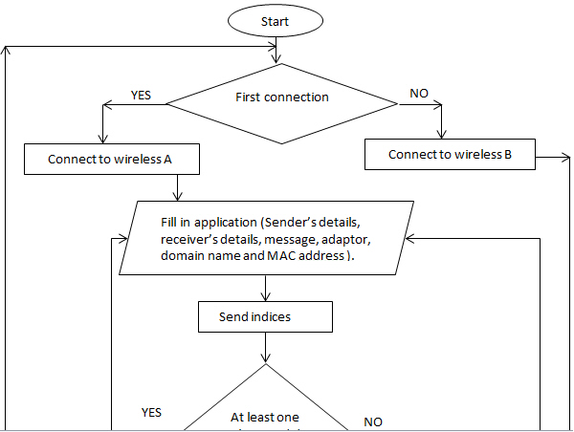
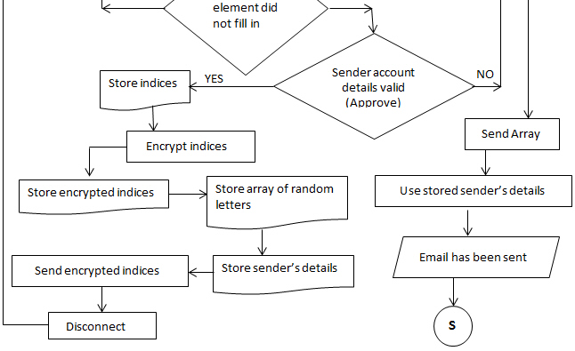
Changing MAC address is part of our security strategy intended to mislead MitM because, each sender’s wireless card (Network Interface Card NIC) has a unique MAC address provided with every packet sent from this sender’s device to denote the sender’s source even with different wireless connection. When the MitM attempts to hack a connection and intercepts its packets, he is focused on displaying all MAC addresses and IPs and once he finds two MAC addresses which have the same hexadecimal values, he will recognise that these two packets are sent from one sender. Matching the two packets then will provide readable data. So, in my opinion changing MAC address is required in our case study.
Encrypting indices using sender’s private code is one of our security processes to thwart any attempt that MitM can try to do to match two data packets together.
Next, the sender’s system passes the packet over channel two that been provided by ISP2 which includes encoded data. An example of the encoded data is shown in Fig.3 which contains encoded indices.

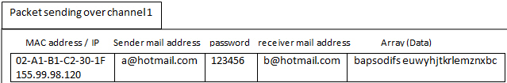
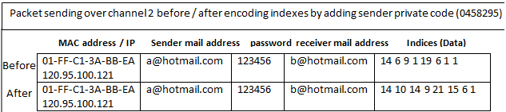
Fig.3 Data encryption and transition

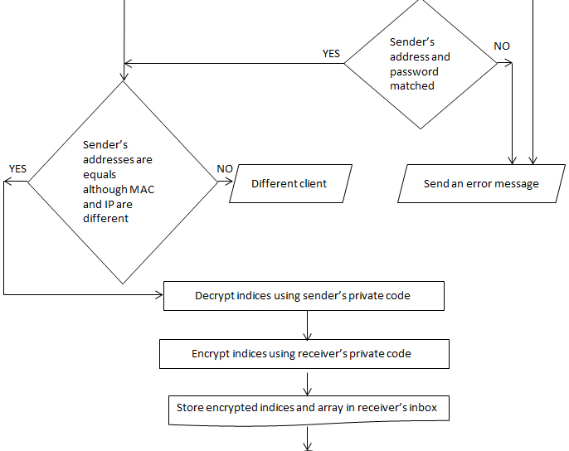
The encoding is done by adding each private code to the original indices. If the indices are longer than the private code, a for loop will iterate from the beginning of the private code until the indices are traversed. When the system changes the MAC address, and data transferred over different channels with different IPs, the server will not recognise which packets come from the same source in order to match them. As an added benefit the MitM will not be able to match indices with the array by decoding. So, the server’s system will recognize that by the sender’s email address itself and it will be known these two packets came
from one source. The process of the sender’s system follows the same flowchart in Fig. 4.
Every webmail server has the ability of knowing each address’s passwords and private code by storing each email
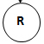
address with its password and private code in a database. Thus, when the server’s system receives these two packets,

Fig.4 Flowchart of sender’s system process

the packet which includes the encoded indices will be decoded by subtracting the sender’s private code from the
encoded indices. It then re-encodes indices by adding the receiver’s private code to the original indices using the same sender’s system decoding methodology. For example, according to Fig.3, if the message that needs to be sent is " hi aliaa ", the original indices for this message according to generated array (bapsodifs euwyhjtkrlemznxbc) are
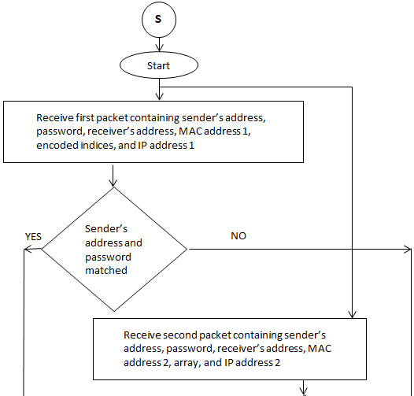
"14 6 9 1 19 6 1 1", but the system is going to encode indices by adding the sender’s private code for example (0458295) to each index to become "14 10 14 9 21 15 6 1", and then when the server receives indices packet, he decodes these indices by subtracting them from sender’s private code for example (0458295) to get original indices and after that, he re-encodes them by adding receiver’s private code for example (1234560) to the original indices to become " 15 8 12 5 24 12 1 2 " . Finally, server’s system store decoded indices and array in the receiver inbox. The process of the receiver’s system follows the same flowchart in Fig. 5.

Fig. 5 Flowchart of server’s system process
When the receiver checks email, the server's system will send the array and decoded indices to the receiver's system, then the receiver's system decodes the indices by subtracting the receiver's private code from the decoded indices to get the original indices "14 6 9 1 19 6 1 1" before matching each index with its letter in the array to get a readable message (hi aliaa). The receiver’s system uses the same methodology.
In Figs. 4 and 5, a flowchart is set of different symbols linked together by arrows to represent the process and showing the process directions. Each step in the process has its different symbol to represent its function in the process.
These symbols represented in different shapes, and each shape represents its own function. An oval shape refers to the begin and the end of a process, a rectangular shape refers to a step/function in the process, a diamond shape refers to a part of the process for making a decision and based on the result of that decision the process continues its direction, circular shape refers to jump to another flowchart to make its process, a parallelogram refers to data input or output for a process, Document refers to a document or report, and arrows refers to the process direction [36].

man in the middle (Mitm)
We now study one of the most common network attacks MitM. A MitM intercepts a message exchange by impersonating each end-point and controls the communication by making the participants believe that they are talking to each other directly in secure connection.
A number of approaches to thwart MitM attacks have been developed, for example cryptographic protocols provide a form of endpoint authentication [13].
In our network model we model the case of multichannel data communication between client and server. The multichannel data transmission system protects against both active and passive interception. Active interception results in altered communication by impersonation or changing the data; passive MitM attack is eavesdropping.
The attack can occur in two ways: (i) the attacker controls a router throughout the normal point of traffic communication between two communicating systems or (ii) the attacker is exist on the same broadcast domain with one of the systems [25]. An attacker may use several tools that are efficient in LAN networks like packet creator, Ettercap, and Dsniff. The tools manifest Arp spoof capabilities that permit interceptions.
The MitM can attack and modify HTTP because HTTP traffic is unencrypted and contains no authentication. They can also attempt to intercept HTTPS traffic by using a custom certificate. The attacker may use proxy tools like Paros Prox and Proxy Fuzz to interact with the HTTP protocol [16].
Hacking depends on software or tools which sniff all signals around the hacker and browses all their IPs. The hacker selects one of that IPs and starts intercepting its packets, to eavesdrop on all data and possibly change it before forwarding the packets to the server.
This technique may depend on hacking the ISP itself to intercept chosen packets. Transmission often works by using only one channel to transfer data and this may be the main reason that makes the data easy to be hacked. However, in our approach the attacker will get an unreadable message once they intercept any one IP, because information is transmitted over two channels with different IPs.

V. Modelling data transmission security over multichannel wireless in Alloy

Before implementing our system, we consider modeling it using the Alloy analyzer to check the reality, privacy, confidently, satisfiability, and security. The model describes how security in data transmission between two hosts over multichannel is achieved, by making explicit the relation between the objects that responsible for the system operation. We next present our methodology.
We first translate the process shown in Fig.2 into the wireless Network communication, where Data transmission between two Actors requires there to be parties that send and receive a Packet via ISP. Each Packet contains two parts, Header and Data. Header contains IP address, and Data contains Changable_Array, indices, and MSG.
The Client chooses an ISP, for example ISP_A to provide them with the service. ISP_A connects Client to the Network and returns a Packet to the Client containing IP (xxx.xxx.xxx.xxx). Client will receive the Packet that is sent by ISP_A and then will require a Server from ISP_A to transmit Data. ISP_A will enquire about that Server over the Network, the Network will provide the ISP_A to that Server. Then the ISP_A receives that Server and forwards it to the Client.
When the Client gets what the forwarded ISP_A, she will start to send her Packet including her Message. At that time, the Client's system will generate a Packet containing Changeable_Array, in which each letter in the Message is matched with the right one in the Changeable_Array, all indices are stored in a file, and then encoded by adding them to the password.
The Client's system will send a Changeable_Array over the ISP_A channel, the ISP_A passes this Packet to the Server's system and then the Server's system receives the Packet over channel 1. Next, Client disconnects the connection with ISP_A and chooses a different ISP, for example, ISP_B. ISP_B will return a Packet containing IP address (yyy.yyy.yyy.yyy) to the Client.
Client gets that Packet and then the Client's system sends encoded indices over ISP_B channel. ISP_B passes this Packet to the Server's system and then the Server's system receives this Packet over channel 2. Once Server's system has two Packets, with the Array and the encoded indices, the indices will be decoded using the sender's password and re-encoded using the receiver's password. The indices are then forwarded to the receiver's system which will match each Index with its location in the Array to extract the Message after decoding indices with the receiver's password. This readable Message is then forwarded to the receiver.
Our model uses 14 signatures. These signatures are Network, Changable_Array, indices, Time, IP, Packet, Header, MSG, password, Actor, ISP, Database, Data, and Actor_sys. Each signature indicates its un-interpreted elements and atoms. The signature IP is defined as a subset of signature Header and allows us to specify the source and the destination of a transmitted packet; In addition, IP, MSG, and Header signatures belong to the signatures Packet , Header, and MSG. Packet is an abstract signature so all elements are a subset of the elements in any signature belonging to Packet
Signatures can extend others to inherit their field and constrains. Extensions of a shared signature are independent (disjoint). Time, Actor, Data signatures are subset of the signature Packet, Actor_sys and ISP signatures are subset of the signature Actor. A signature can also be represented as a subset signature; subset signatures of a shared parent are not independent. Five signatures do not have relations: Changable_Array, indices, Time, IP, and MSG.
Header has a relation which includes IP, while Network has an indirect relation with ISP and a direct relation with Actor. Packet builds six relations with other signatures to identify the source and target which allows us to write assertions about the identity of the participants in the communication. There are including relations between Packet and signatures Actor, Time, Header, MSG, Changable_Array, and indices, as Packet includes all those signatures. Some signatures have a direct relation with others, for example sender_chooses between Actor and ISP. Also there is an indirect sender_Requests relation between Actor and ISP.
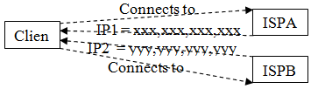
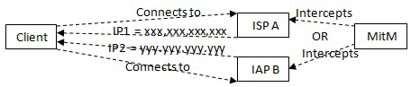
The first predicate in our model is designed to guarantee that Client connects to different ISPs A and B each time because it should not connect and reconnect to the same ISP in anticipation other existence of a MitM attack on this ISP. We make a restriction to confirm that, as shown in Fig. 5, the ISP that Client chooses to connect to the first time should not be equal to the ISP in the second time and that will indicate the IP that Client received at the first connection with ISP A is completely different to the IP that it received from the second connection with ISP B for the same host. See Fig. 6.

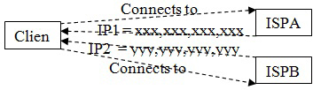
t

Fig. 6 A client connects to different ISPs

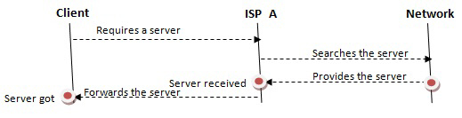
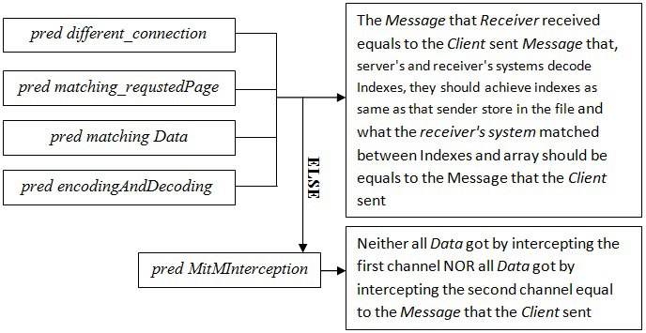
The second predicate as seen in Fig. 7 is designed to guarantee that there is no MitM between Network, ISP and Actor. We make a restriction to confirm that the server that Network provides to ISP_A equals that which ISP_A was looking for and, the server that ISP_A received from Network equals the Server that Network provided to ISP_A. In addition, the server that ISP_A forwarded to Client equals the server that the Client requested from ISP_A and the server that Client gets from ISP_A equals what the ISP-A forwarded to the Client. This predication would be the same with the second connection to ISP B.
Fig.7 Data transition over multichannel

The third predicate is designed to guarantee that Changeable_array and indices are transmitted over multichannel to guarantee security without any modification by MitM, and once any hacking happens, the MitM will not get any readable message. We make a restriction to confirm that, as shown in fig. 7, the Changeable_array that is received by server over ISP_A is equal to the Changeable_array that Client sent over ISP_A, and the indices that is received by server over ISP_B is equal to the indices that Client sent over ISP_B. See Fig. 8.
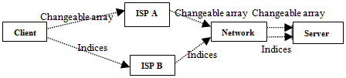
Fig.8 Array and indices transition over multichannel

The fourth predicate is designed in terms of hacking by MitM, to guarantee that even with MitM, Data transition is still secure. We make a restriction to confirm that when Client connects to different ISPs, the MitM may intercept one of them and got nothing. See Fig. 9.

Fig.9 MitM hacking one of the multichannel

The last predicate is designed to guarantee that when the server's and receiver's systems decode indices, they should achieve the same indices as the sender stores in the file, as shown in Fig. 3.
Assertions are used to seek a counterexample. After checking the assertions, if there is a counterexample then there is missing or incorrect restriction on the automaton to limit the sequence of independent states, and the relations of the model fail. If no counterexample is found the model and its relations are correct and consistent.
Example runs are shown in Fig. 11. If the Client submits her data over multichannel it will achieve a secure data transition. Even if a MitM may intercept one of these channels and as result they will get an unreadable Message. Because, to get a readable Message, they should intercept both channels and this does not occur in our model. Procedure of analysing our model using Alloy is given in Fig. 10. The complete Alloy specification of our model can be downloaded http://www.macs.hw.ac.uk/~aa989/

Fig. 10 Meta-Alloy model.

Evaluation
We check that our model does not find a counterexample which suggests that the characteristic of the objective of our model are satisfied.
Fig. 11 shows example means total times to check and generate model and fetch counterexample if one exist. The standard deviation for running our model 15 times to seek a counter example is 1.41 ms.
Our model is based on one client, one server and one MitM. Increasing the number of actors will make the model more complex. In this case the aggregation of the Alloy signatures and tasks will be more complicated to relate, and assertion and predicates may require more detail.
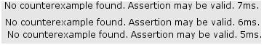
Fig.11 Checking for counterexamples: time complexity

related work
Interest in multichannel security protocols field is growing [11],[14],[15], [17],[24],[26],[27]. For example, a protocol called Multi-channel MAC Protocol has been studied by [15]. This protocol using a technique called Cognitive Radio (CR) to prevent DoS by a radio jamming attack in a wireless network. This kind of attack takes place if the device uses single channel communication, making it easy for eavesdroppers to send and receive radio signals or packets to confuse the original client transmission, which leads to DoS. Multichannel MAC protocol is one of the suggested solutions for that problem. It utilizes CR which has two technologies responsible for obstructing jamming attack. The first is real time spectrum sensing and the second is fast channels switching [15]. The disadvantage is that using lots of channels in this protocol can cause higher channel sensing time.
Multi-hop communication with access to multichannel MAC (medium access control) protocol was used by [17] to reduce the problems in a Wireless Mobile Ad hoc Network (MANET), such as conflict and collision caused by increasing the number of mobile hosts quickly decreasing the performance of the network. This protocol was designed for wireless networks which assume a joint channel exchanged by mobile hosts. The protocol works by utilizing static channel activity and applying IEEE 802.11 in the sending and receiving operations on every channel. This protocol faced problems of hidden terminal and exposed terminal. To eliminate those problems, in the multichannel MAC protocol called dynamic channel assignment (DCA) [17], bandwidth is separated into two types of channel. A single control channel (Control transceiver) is used to solve confliction problems and allocate data channels to mobile hosts. Then a number of data channels (Data transceiver) are used to submit data packets and acknowledgement through switching between data channels. This protocol has the ability to support mobile communication between two hosts and has comparable simplicity to our approach.
Relay attacks are studied by [18], [19], [20]. According to [18], encryption alone may not protect all communication between two parties from MitM and they propose multichannel protocols to prevent relay attacks a solution is to add another channel so two endpoints can establish if they are connecting to each other securely or if there is a MitM intercepting them. The main characteristic of this extra channel is that it is difficult for it to be relayed. The technique is based on a distance bounding protocol to provide connection approval with a low force security guarantee like "it probably is, provided there are no other principals within d meters of verifier". The main goal of the distance bounding protocol is giving the ability only to the genuine prover to respond to the challenge whereas the MitM never responds to the challenge because he does not have any idea about the shared secret. Our approach is similar; we model secure message exchange over a multi-channel network making similar assumptions.
An analysis of a relay attack [19] depends on speed, by calculating how much time sending and receiving data take depending on the theory of the speed of light. This defensive technique is limited and works on establishing if the right prover is farther away than predicted. The same solution is reported by [20] but with a high security low level protocol with pre-calculation of one bit challenge and response which transmits as fast as the channel allows. In contrast, we are not concerned with the speed of the message exchange. Instead we capture only the intended sender and receiver and the relevant properties of encryption and description for a secure exchange to take place.
In multichannel key agreement, using encrypted public key exchange, secure communication is achieved by sending and receiving messages that can be easy to eavesdropped or changed through public channels. To make fresh strong cryptographic key agreement between two PDAs, Diffie-Hellman (DH) key exchange may be used to guarantee security, conﬁdentiality, integrity, and authenticity in data transition [21], [22].
This protocol accomplishes similar goals to [23] but there are further goals this protocol achieved compared to [23] such as, neglecting for how long the hacker tries to hack the second channel, this protocol could decrease the ability of hacking second channel data transition to less than 1 in 1000,000 by taking in account using of bandwidth of the second channel worthily. Another goal which considered as main goal is that, this protocol does not attention on submitting data via the second channel for proving equality but for computing subsequent protocol values [24] and this is another difference to [23].
Sharing a secret among two devices such as camera phone and sharing printer by radio and through a channel without approval, is a problem. Diffie-Hellman (DH) key exchange is a method provides security that symmetric cryptography cannot do to eliminate eavesdropping. The protocol provides robust security for data and is transmitting over two channels. Its technique works by merging long values submitted via radio channel with short values submitted via the data origin authentication channel [23]. In contrast, our approach assumes perfect encryption. The breakdown of the message into parts is for illustration only.

CONCLUSIONS & Future work
We propose a model for a multi-channel wireless network which provides security to one simple, scalable communication and data transition between two parties from MitM attack. We have modelled and checked our system using Alloy, which has provided formal assurance that it is secure; that is, our design guarantees that the security of emails transmitted over multichannel is stronger compared with data transmitted over a single channel. Analysis of the model using Alloy has a limited scope and is dependent on the predefined signatures and assertions intended to ensure precise modelling of the communicating parties and security constraints. To provide further assurance that our system is consistent with the model, we plan to investigate an alternative approach. We will use the theorem prover Z3 to verify that the system is correct relative to assertions about the model. Similarly to Alloy, Z3 is an automated satisfiability checker for typed first-order logic, which uses theorem proving instead of SAT solving as an underlying mechanism to guarantee assertions. In the case where more than one client communicates with one server, we suggest adding a "temporary database" to extend the system, storing all packets that are sent by different clients to a specific server and then matching every two correct packets together to extract readable message by using push and pop methodology. This may take much longer time when the server is busy because the system may be malfunctioning and need to re-start.

References
[1]. L. Buttyan, J. Hubaux, Security and Cooperation in Wireless Networks : Thwarting Malicious and Selfish Behavior in the Age of Ubiquitous Computing, New York: Cambridge University Press, 2008, p. 5-6.
[2]. P. Khan, T. Dai, C. Hong, " An Efficient LU Decomposition-based Key Pre-distribution Scheme for Ensuring Security in Wireless Sensor Networks," CIT \'06 Proceedings of the Sixth IEEE International Conference on Computer and Information Technology , p.227, 2006 .

[3]. E. Clarke, " Model checking," Foundations of Software Technology and Theoretical Computer Science, Vol. 1346, S. Ramesh, G.Sivakumar (Eds.), Ed India: Die Deutsche Bibliothek, p. 54-56, 1997.
[4]. E. Clarke. "The Birth of Model Checking", 25 Years of Model Checking, Vol. 5000, O. Grumberg and H. Veith (Eds.). Lecture Notes In Computer Science, Springer, Berlin, Heidelberg , p. 1-26, 2008.
[5]. B. Braem, I. Moerman, C. Blondia, P. Demeester " A survey on wireless body area networks," Wireless Networks , Vol. 17, p. 1-18, 2011 .
[6]. D. Gritzalis, J. Lopez, Emerging Challenges for Security, Privacy and Trust. Proceedings of the 24th IFIP International Information Security Conference 2009 (IFIP SEC'09), IFIP AICT , Springer, 2009, p. 76-86.
[7]. C. Andrew , P. Radha , 1st Initial. , "A Metric for Quantifying Key Exposure Vulnerability in Wireless Sensor Networks," Wireless Communications and Networking Conference (WCNC), IEEE, p. 1-6, 2010
[8]. Information Security Policy, < http://policy.nd.edu/policy_ files/ InformationSecurity Policy.pdf > ,(accessed March 1, 2012), 2009.
[9]. D. Jackson, Software Abstractions: Logic, Language, and Analysis. New Cambridge, Massachusetts, London, England: The MIT Press, 2006, p. 399.
[10]. P. Zave. Lightweight modeling of network protocols in Alloy, 2009.
[11]. F. Wong. Protocols and technologies for security in pervasive computing and communications. Technical , University of Cambridge, Computer Laboratory, Cambridge : Computer Laboratory, p.167, 2008.
[12]. D. Carts, A Review of the Diffie Hellman Algorithm and its Use in Secure Internet Protocols, SANS Institute, 2001.
[13]. U. Meyer, S. Wetzel, " On the impact of GSM encryption and man-in-the-middle attacks on the security of interoperating GSM/UMTS networks," Personal, Indoor and Mobile Radio Communications, PIMRC , 15th IEEE International Symposium on, Vol. 4, p. 2876 - 2883, 2004.
[14]. H. John, R. Jyri, and H. Taina. "DSiP distributed systems intercommunication protocol: a traffic engineering solution for secure multichannel communication" In Proceedings of the 10th WSEAS international conference on communications, electrical & computer engineering, and 9th WSEAS international conference on Applied electromagnetics, wireless and optical communications (ACELAE'11), Nikos Mastorakis, Valeri Mladenov, and J. Savkovic-Stevanovic (Eds.). World Scientific and Engineering Academy and Society (WSEAS), Stevens Point, Wisconsin, USA, p. 57-60, 2011.
[15]. Z. Htike, C. Hong .Cognitive Radio Based Jamming Resilient Multi-channel MAC Protocol for Wireless Network, <http://networking.khu.ac.kr/publications/data/Cognitive%20Radio%20Based%20Jamming%20Resilient%20Multichannel%20MAC%20Protocol%20for%20Wireless%20Network.pdf >, p. 1-2, 2009.
[16]. OWASP 2009, Man-in-the-middle attack, <https://www.owasp.org/index.php/Man-in-the-middle_attack>, 2009.
[17]. S. Wu, C. Lin, Y. Tseng, and J. Sheu, "A New Multi-Channel MAC Protocol with On-Demand Channel Assignment for Multi-Hop Mobile Ad Hoc Networks," International Symposium on Parallel Architectures, Algorithms and Networks (ISPAN), Dallas, TX, Dec. 2000.
[18]. F. Stajano, F. Wong, B. Christianson, "Multichannel Protocols to Prevent Relay Attacks," Proceeding Proceeding FC\'10 Proceedings of the 14th international conference on Financial Cryptography and Data Security , p. 4-19, 2010.
[19]. Y. Desmedt, G. Claude, S.Bengio, " Special Uses and Sbuses of the Fiat-Shamir Passport Protocol", In A Conference on the Theory and Applications of Cryptographic Techniques on Advances in Cryptology (CRYPTO '87), Carl Pomerance (Ed.). Springer, London, UK, p. 21-39, 1987.
[20]. S. Brands, D. Chaum, "Distance bounding protocols", Advances in Cryptology EuroCrypt, Vol. 765, T. Helleseth (Eds.), Lecture Notes in Computer Science, p.344-359, 1993.
[21]. J. Li et al., "Fair Authentication in Per-vasive Computing", Secure Mobile Ad-hoc Networks and Sensors, Vol. 4074, M. Burmester , A. Yasinsac (Eds.), MADNES05, LNCS, p. 132–143, 2006.
[22]. W. Diffie and M. Hellman. "New Directions in Cryptography", IEEE Transactions on Information Theory, Vol. 22 ,p. 644–654,1976.
[23]. F.Wong, and F.Stajano. "Multi-Channel Protocols: Strong Authentication using Camera-Equipped Wireless Devices", Security Protocols 13, LNCS, Vol. 4631, p.112–132, 2007.
[24]. B. Christianson, J. Li, “Multi-channel key agreement using encrypted public key exchange". Proceedings of the 15th international conference on Security protocols, B. Christianson, B. Crispo, J. Malcolm, M. Roe (Eds.). Springer, Berlin, Heidelberg, p. 133-138, 2007.
[25]. Security, “Man-in-the-Middle Attack (MITM) ", < http://www.techopedia.com/definition/4018/man-in-the-middle-attack-mitm > ,(accessed July 12, 2011).
[26]. L. M. Feeney, B. Ahlgren, A. Westerlund, "Spontaneous Networking: An Application-Oriented Approach to Ad-Hoc Networking", IEEE Communications Magazine, Vol. 39, p. 176–181, 2001.
[27]. F. Stajano , R. Anderson. "The Resurrecting Duckling: Security Issues for Ad-Hoc Wireless Networks", Security Protocols, LNCS, Vol. 1796, B. Christianson, B. Crispo, J. Malcolm , M. Roe (Eds.) , p. 172–194, 2000.
[28]. F. Mostefaoui, F. & Vachon, J. " Verification of Aspect-UML models using alloy". AOM '07: Proceedings of the 10th international workshop on Aspect-oriented modeling, p. 41-48, 2007.
[29]. D. Jackson, ªAlloy: A Lightweight Object Modelling Notation,º
Technical Report MIT-LCS-797, MIT Laboratory for Computer
Science, Cambridge, Mass, Available at: http:// sdg.lcs.mit.edu/~dnj/publications, 2000.
[30]. D. Divya Prakash Nigam and Aparajita Ojha. An aspect oriented model of efficient and secure card-based payment system. In Proceedings of the International Conference on Communication, Computing & Security (ICCCS '11). ACM, New York, NY, USA, p. 559-564, 2011
[31]. K. Anastasakis, B. Bordbar, G. Georg , I. Ray, “UML2Alloy: A Challenging Model Transformation", Model Driven Engineering Languages and Systems, Vol. 4735, G. Engels, B. Opdyke, D. Schmidt , F. Weil (Eds.), p. 436-450, 2007.
[32]. M. Taghdiri and D. Jackson, "A lightweight formal analysis of a multicast key management scheme", 23th International Conference on Formal Techniques for Networked and Distributed Systems (FORTE), Vol. 2767 of LNCS, p. 240-256, 2003.
[33]. G. Georg , J. Bieman , R. France. "Using Alloy and UML/OCL to Specify Run Time Con¯guration Management: A Case Study". Practical UML-Based Rigorous Development Methods Countering or Integrating the eXtremists. Vol. P-7 of LNI, p. 128-141, 2001.
[34]. G. Dennis, R. Seater, D. Rayside, D. Jackson. "Automating commutatively analysis at the design level" , ISSTA '04: ACM SIGSOFT international symposium on Software testing and analysis, ACM Press, p. 1-11, 2004.
[35]. A. Lin , M. Bond , J. Clulow . " Modeling Partial Attacks With Alloy", Proceedings of the 15th international conference on Security protocols, B. Crispo, J. Malcolm, M. Roe (Eds.), Springer, Berlin, Heidelberg,p.20-33, 2007.
[36]. N. Hebb, What is a Flow Chart, < http://www.breezetree.com/articles/what-is-a-flow-chart.htm>, (accessed May 10, 2012), 2006.

