Explaining Polymorphic Types Through Visualisation

Yang Jun
Heriot-Watt University
Dept of Computing & Electrical Engineering, Riccarton,
EH14 4AS
ceejy1@cee.hw.ac.uk

Greg Michaelson
Heriot-Watt University
Dept of Computing & Electrical Engineering, Riccarton,
EH14 4AS
greg@cee.hw.ac.uk
http://www.cee.hw.ac.uk/~greg

Phil Trinder
Heriot-Watt University
Dept of Computing & Electrical Engineering, Riccarton,
EH14 4AS
trinder@cee.hw.ac.uk
http://www.cee.hw.ac.uk/~trinder

Abstract
A 2D visualisation of polymorphic types is presented. A pilot experiment to evaluate the use of the visualisation with novice functional programmers is reported and the visualisation’s incorporation in a visual programming environment is discussed.

Keywords
Polymorphic types; Visualisation; Functional programming; Standard ML; type inference.

Introduction
Polymorphic type systems combine considerable generality in software component definition with precise static analysis of specific component use. Such type systems have their origins in Church’s λ calculus and have been most prominent in functional languages, which themselves originated as vehicles for theory of computing research. It is now widely recognised that functional languages bring many pedagogic benefits in bridging theoretical and practical aspects of Computing. Consequently, they are widely taught as part of the undergraduate Computing curriculum.
A polymorphic type system attempts to deduce a principle type for a software component. It does so by making very general assumptions about the types of component sub-constructs and then unifying types which should be the same. To begin with, type variables which may be instantiated with any type are assigned to sub-constructs. During unification, type variables may be instantiated to specific types. At the end of type checking, if type variables are still present in the type, then the software component is said to be polymorphic, that is the component may be used in many different specific type contexts. For example, the Standard ML(SML)[1] function:
Permission to make digital or hard copies of all or part of this work for personal or classroom use is granted without fee provided that copies are not made or distributed for profit or commercial advantage and that copies bear this notice and the full citation on the first page. To copy otherwise, to republish, to post on servers or to redistribute to lists, requires prior specific permission.
7th Annual Conference on the Teaching of Computing, Belfast
© 1999 CTI Computing

fun sum [] = 0 |
sum (h::t) = h+sum t
adds all the elements of an integer list to return an integer. Thus its type is:
fn : int list -> int
indicating that its domain is a list of integers and its range is an integer. Note that the system deduces that the result is an integer because in the base case the result is 0. Thus, the recursion case h+sum t must also return an integer so h must be an integer and (h::t) must be an integer list.
In contrast, the function:
fun length [] = 0 |
length (h::t) = 1+length t
has type:
fn : ‘a list -> int
The result is an integer but nothing is done with the elements of the list. Thus, it may be a list of any type, denoted here as ‘a list where ‘a (read “alpha”) is a type variable..
Now consider:
fun last v [] = [v] |
last v (h::t) = h::last v t
which puts v on the end of the list (h::t) . This has type:
fn : ‘a -> ‘a list -> ‘a list
indicating that if the argument v is of some type then the argument list (h::t) and the result list will be of the same type.
Our experience of teaching SML to students with previous imperative experience of Pascal or C++ suggests that a number of difficulties in understanding polymorphic types may be encountered. For example, a more general type may be deduced than was anticipated or an arithmetic overload type error may occur where an imperative language would enforce a coercion. However, the main problem seems to lie in understanding type variables, especially as they behave differently to program variables. For example, consider:
fn a => fn a => fn a => a+1
Here, each variable a is declared in a new scope, so this curried function has type:
fn : ‘a -> ‘b -> int -> int
It may be applied to three different arguments, to effectively discard the first two and to add 1 to the last. In contrast, in the type:
fn : ‘a -> ‘a list -> ‘a list
for last above, all occurrences of the type variable ‘a must be instantiated to the same type.
We wish to investigate whether the use of a 2 dimensional visualisation might aid in the understanding of polymorphic types, in particular, to form a basis for a dynamic presentation of type unification during function application, to illuminate the simultaneous instantiation of all occurrences of a type variable with a common type.
Note that there is some ambiguity as to the status of type checking in the following sense. Tasks may be characterised as symbolic or spatial and there is experimental evidence that textual presentations are more suitable than visualisations for symbolic tasks[2]. Programming is predominantly learnt as a symbolic activity, and there is evidence that visual programs are harder to read than textual programs[3]. However, type checking of function application might also be viewed as a spatial activity because of the simultaneous substitution of type variables discussed above.

The Visualisation
In the 1st Year Functional Programming module at Heriot-Watt University, students with 1 term’s experience of C++ are taught a pure functional subset of SML[4] including integer, real, boolean, string, tuple and list types. Thus, our visualisation was initially aimed at these. We decided that a type would be represented by a rectangle with internal structure and colour corresponding to its component types. In this paper, black and white shadings are used to illustrate the visualisation. Base types are represented by solid colour (Figure 1). Tuple types are represented by juxtaposed rectangles of field types (Figure 2 left) and list types as the component type within a distinctive brace (Figure 2 right). Type variables are represented by an empty rectangle containing the type variable (Figure 3 left) and function types by a sequence of curried domain types along the top from the left with the range type in the bottom right hand corner (Figure 3 right).
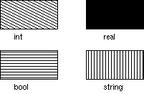
Figure 1: Base types

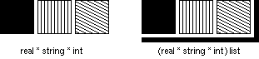Figure 2: Tuple and list types

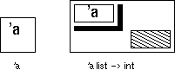
Figure 3: Type variable and function type
A major benefit of the visualisation is that it provides a graphical means to show simultaneous substitution of type variables during function application. b with int. This is illustrated in Figure 4.
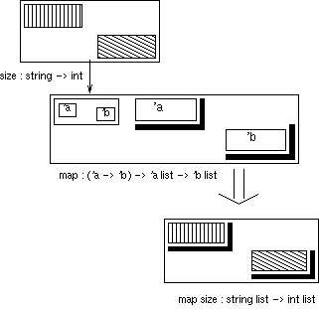Figure 4: Applying map to size
The map function (middle):
fun map f [] = [] |
map f (h::t) = f h::map f t
fn : (‘a -> ‘b) -> ‘a list -> ‘b list
applies some function f of type ‘a -> ‘b to every element of an ‘a list to produce a ‘b list. The function size (top) of type string -> int returns the length of a string so mapping size over a list of strings returns a list of their lengths:
e.g. map size [”a”,”bc”,”def”] ==>
[1,2,3]
When map is first applied to size, ‘a -> ‘b for f must unify with string -> int so ‘a must be consistently replaced with string and ‘b with int ( bottom).
Furthermore, our visualisation clarifies the differences between apparently similar types. For example, Figure 5 shows how the visualisation may be used to discriminate between the int -> int -> int and (int -> int) -> int types (top), and between the int * int -> int and int * (int -> int) types (bottom).

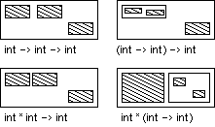

Figure 5: Differentiating similar types

Evaluation

Experimental method
We wished to compare the use of the visualisation with that of the normal textual representation in solving type resolution problems. We elected to make comparison by measuring the speed and accuracy with which students could solve a number of type unification questions. The questions are ranked by the number of type variables in each unification; a good measure of their difficulty.
Ordinarily, students would only use a text based functional programming environment so the module lectures were augmented with visualised type diagrams for every function that was discussed. However, the students only worked with textual type representations in their practical work. At the end of the module, students answered sets of questions which involved identifying the resultant type from applying a function of given type to an argument of given type.
We wanted to see whether there were any transferable learning effects from visualisation based problems to textual based problems or vice-versa. Two sets of multiple choice questions were prepared, where the second was the same as the first but with both different base types and different answer orders in each question. In the evaluation, one group of students would attempt a visualised version of the first set while another group attempted a textual version of the same set. The first group would then attempt a textual version of the second set while the second group attempted a visual version.
In each set there were 20 questions comprising 6 with no type variables, 3 with 1 type variable, 9 with 2 type variables and 2 with 3 type variables. For each question there were six optional answers: four different type unifications, none of the above or type error. Figure 6 shows an example visualised question. Note that the visualised questions also contained text.
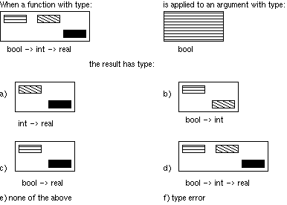
Figure 6: Visualised question

Experimental results
16 students took part in the evaluation, divided into 2 groups of 8. At the start of the evaluation, all subjects were given a brief presentation on the visualisation. Each group then had two periods of 10 minutes in which to answer the question sets. For each subject, the number of wrong answers and the number of unanswered questions were recorded. Note that the sample size is really too small to draw other than indicative conclusions.
On average, the group that answered visualised questions before textual questions made less mistakes but answered less questions on the visualised set. On average, the group that answered textual questions before visualised questions made less mistakes but answered marginally less questions on the textual set. Perhaps both groups had lost interest before the second set?
T-tests indicate no significant differences between the groups so all visualisation results and all textual results were combined. Figure 7 shows the average number of wrong answers and unanswered question by question type. Overall, on average there are slightly more wrong textual answers and there are more unanswered visual than textual questions.
 | Textual | Visual
Wrong/(20*16) | 6.7 | 6.3
Unanswered/(20*16) | 0.6 | 1.3
Figure 7: Average wrong and unanswered questions for 16 students each answering 20 questions
Figure 8 shows graphs of the average numbers of wrong answers and of unanswered questions, in proportion to the number of questions in each category. With the visualisation, there are less wrong answers on questions with one and three type variables and more unanswered questions on those with two and three type variables. Overall, for both visualised and textual questions, there are more mistakes and more unanswered questions as the number of type variables increase. However, there are no discernable differences between the visualised and textual questions for the number of mistakes or of unanswered questions.
Figure 8: Proportions of wrong answers and unanswered questions by question group

Discussion
At best we can conclude that the visualisation is no worse than the textual approach. However, the students had 10 weeks practical experience with the standard textual approach compared with brief passive exposure to the visualisation in the same period. Furthermore, the visualisation was intended for use within a dynamic programming environment but has been evaluated for static problem solving. Thus, we are not discouraged from further investigation of its dynamic use.

Implementation
A prototype visual programming environment has been developed for the pure functional subset of Standard ML that we teach. The system is written in C with Motif and runs under X Windows on UNIX. Within the system, the function is the basic unit of visualisation: there is no visualisation of lower level program detail which are dealt with as text. The system displays values in a 2D area as icons based on their types in the above form, extended with the function name, and controls for moving icons and interconnecting icons. For further details, see[5].
A function is applied to a value by linking the bound variable type on the function icon to the value’s icon. The system then dynamically unifies the function and value types to create a new icon to represent the result of the application. For example, Figures 9 to 12 shows the application of map to size and then to a list of strings, and are comparable with Figure 4.

Further work
Currently, a core system for type checking visualisation is being written in Standard ML with SML/TK. This will be used to re-implement the visualisation discussed above, as well as forming a basis for further type explanation experiments. The new implementation will be used in practical classes by 1st year students to carry out type checking exercises prior to evaluation. Students will also be asked to carry out tests to determine their relative spatial and textual reasoning abilities[6], to determine if type visualisation suits some people better than others. Student exam marks will then be used to normalise evaluation results.

References
[1] R.Milner, M.Tofte, R.Harper & D.McQueen, The Definition of Standard ML, MIT, 1997
[2] I.Vessey, Cognitive Fit: A Theory-Based Analysis of the Graphs Versus Tables Literature, Decision Sciences, Vol. 22, pp 219-240, 1991
[3] T.R.G.Greene & M.Petre, When Visual Programs are Harder to Read than Textual Programs, In G.C. van de Veer, M.J.Tauber, S.Bagnarola & M.Antavoltis (eds), Human-computer Interaction: Tasks and Organisations, Proceedings of ECCE-6, CUD: Rome, 1992
[4] S.P.Foubister, G.J.Michaelson & N.Tomes, Automatic Assessment of Elementary Standard ML Programs Using Ceilidh, Journal of Computer Aided Learning, Vol 13, pp 99-108, 1997
[5] J.Yang & G.Michaelson, A Visualisation of Polymorphic Type Checking, submitted to Journal of Functional Programming, 1998, available from: ftp://ftp.cee.hw.ac.uk/pub/ym.jfp98.ps.Z
[6] R.Riding & I.Cheema, Cognitive styles - an overview and integration, Educational Psychology, Vol 11, Nos 3 & 4, pp 193-215, 1991

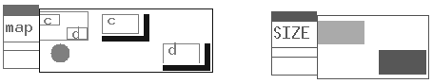

Figure 9: map and size
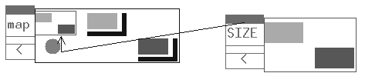

Figure 10: map size


Figure 11: "collapsed" map size applied to ["a","bc","def"]


Figure 12: Final type from map size ["a","bc","def"]

