THREATENING WEATHER
Greg Michaelson

They said I played too fast, too wild.
They claimed I scared the landlord’s cat.
They swore I woke the barmaid’s child.
They stole the pennies from my hat.

But the painter on the cliffs above
Had praised my tuba’s festive air;
Had proffered honour, friendship, love
Were I to pose for his canvas bare.

I played him marches, hornpipes, jigs.
I played him waltzes, lullabies.
I played as dreamscape clouds unfurled
Like wigs across the sea-ward skies.

But he had no hues for my merriment;
He had no brush for my raven hair.
He’d only eyes for my instrument,
My torso cleft and my dining chair.

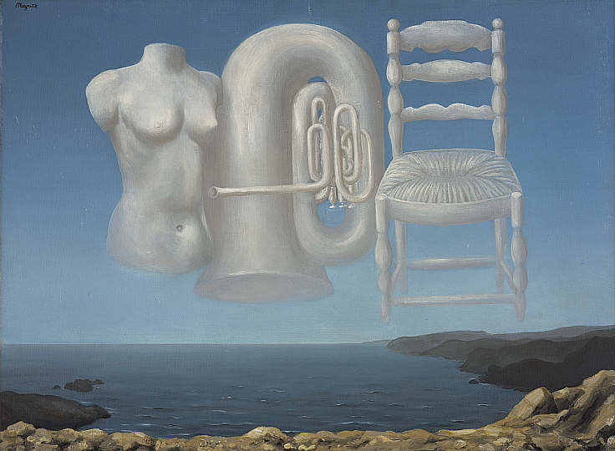
Rene Magritte, Threatening Weather, National Galleries of Scotland
http://www.nationalgalleries.org/media/42/collection/GMA%203887.jpg

