Travel Information Sheet

Jessica Chen-Burger
30 August 2019

This document provides travel information to visit me at the MACS, DCS, Heriot-Watt University

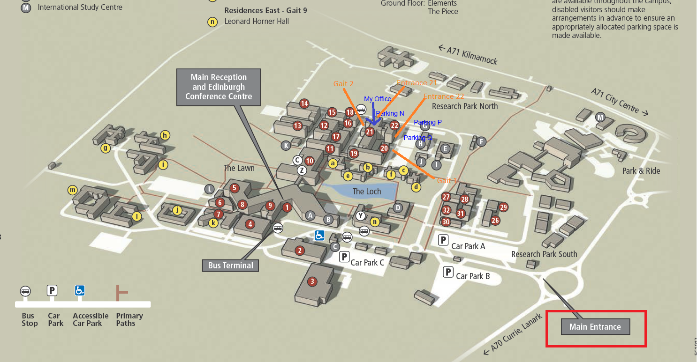
Figure 1: The location of my office (building 21) and car parks available: N, P and Q

Dr. Yun-Heh (Jessica) Chen-Burger
Assistant Professor
Department of Computer Science
School of Mathematical & Computer Sciences (MACS)
Room EM G.38, Earl Mountbatten Building
Heriot-Watt University, Edinburgh, EH14 4AS
United Kingdom
Tel: +44 (0) 131 451-3434
Email: y.j.chenburger@hw.ac.uk; jchenburger.work@gmail.com
URLs: www.macs.hw.ac.uk/staff-directory/dr-yun-heh-jessica-chenburger.htm

Jessica’s Office:

The Earl Mountbatten Building is building 21 on the campus map above, Figure 1.

The building has a north entrance (Mountbatten North entrance, labelled as entrance 21) that is inside of a car park (denoted “N”) and is facing north and a field. It is between Gait 1 and 2. The entrance 21 is the closest door to my office that has a few steps and a slip walk path, a transparent roof with red frame and pillars.

Once you entered the Earl Mountbatten Building, Room G.38 is on the ground floor and to your left. Once you are in the corridor, my office is on your right and towards the end of the corridor.
It normally takes about 30 minutes from Edinburgh city centre to HW Univ. by Taxi; and 40 minutes by Bus 25 from the Princes Street.

Please give me a call when you know approximately when you will be arriving Heriot-Watt Univ., if I do not know already; or call me when you are in a Taxi, so that I can look out for you.

Edinburgh Taxi Telephone Numbers:
- 229 2468 (Central Taxi); or +44 131 229 2468 (international number)
- 228 1211 (City Cab); or + 44 131 228 1211 (international number)

MACS School Office:

Reception
Room 1.24, Earl Mountbatten Building
School of Mathematical & Computer Sciences
Telephone: +44 (0)131 451 3324
Email: macs-schooloffice@hw.ac.uk
https://www.hw.ac.uk/schools/mathematical-computer-sciences/about.htm

If you are visiting MACS’s school reception (EM 1.24), then entrance 22 in the map above is probably a closer entrance, as the school reception is at the first floor adjacent to the building where you enter the door (building 22 - Colin Maclaurin Building).

Once you enter the building (22), walk straight and go up via a staircase on your left. Turn left when you reach the 1st floor, the MACS school reception is on your right.

Driving by Car and Vistior Car Park

If you are travelling by car, the University is at the south west part of Edinburgh. It is half a mile from the Calder Junction of the A720 City of Edinburgh by-pass and the A71, and you’ll see signs for Heriot-Watt University on your approach.

If you are driving by car, the nearest visitor car park is at the north and west of the building.

Taking a Train – off at the Edinburgh Park

If you are taking the train, you could change at the Edinburgh Waverley train station, before making your way to the Heriot-Watt University.

From Edinburgh Waverley train station, any trains whose designations to Milngavie, Helensburgh or Dunblane are suitable.

The train stops are Edinburgh Waverley - Haymarket - Edinburgh Park. For more info, please see: http://ojp.nationalrail.co.uk/service/timesandfares/EDB/EDP/today/1615/dep

Once you have arrived Edinburgh Park, you can take a taxi from there. It takes about 5-10 minute drive to Heriot-Watt Univ.

Taking a Bus from Edinburgh City Center

From Edinburgh city centre, Princes Street, the Lothian Bus 25 is the best one to take (one every 10 minutes). It takes about 40 minutes to the main reception at the center of Heriot-Watt University.

Once you have arrived at the main reception, it will take about 5-8 minutes walking to my office above.

More information: https://www.hw.ac.uk/uk/edinburgh.htm

Appendix 1 – Free WiFi in Edinburgh City Center – this free WiFI should work when you are in Edinburgh city center

https://edinburgh.org/edinburgh-city-centre-wifi/

Appendix 2 – Marriot Hotel (courtyard) on campus

https://www.marriott.co.uk/hotels/travel/edihw-courtyard-edinburgh-west/

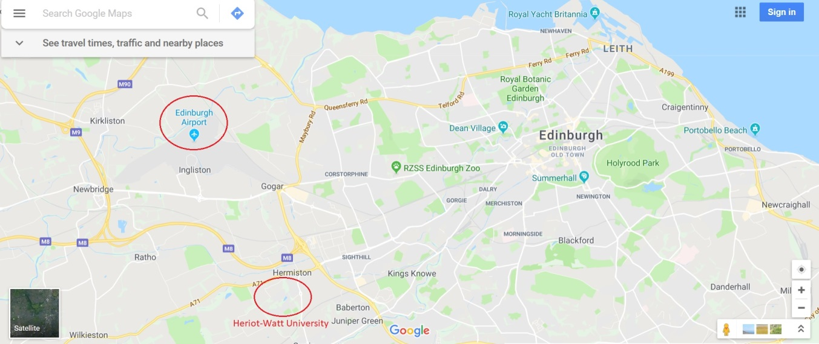

Map of Marriot Hotel and Airport

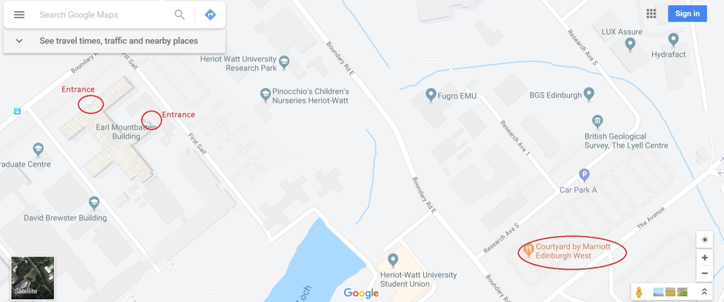

Map of Marriot Hotel and Computer Science Department

